3.1 Quadratic Functions and Models

Quadratic Functions

Let a, b, and c be constants with a ≠ 0.
A function represented by
f(x) = ax² + bx + c
is a quadratic function.

Which of these are quadratic functions?
f(x) = 3x² + 1 is a quadratic function
g(x) = 2x + 1 is NOT a quadratic function
h(x) = 5x² + x - 7 is a quadratic function

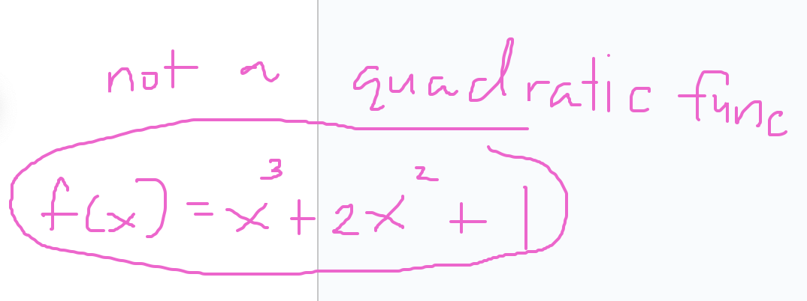

The graph of a quadratic function is a parabola—a U-shaped graph that opens either upward or downward.

A parabola opens upward if a is positive and opens downward if a is negative.

The highest point on a parabola that opens downward and the lowest point on a parabola that opens upward is called the vertex.

The vertical line passing through the vertex is called the axis of symmetry.

Example: f(x) = x²

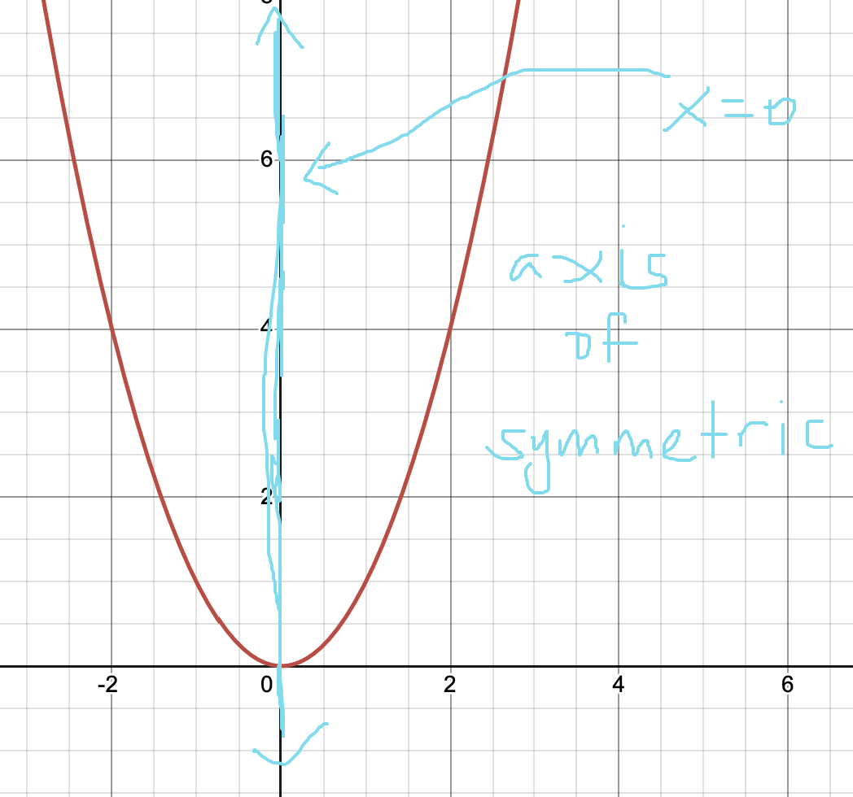

Graph of Quadratic Functions
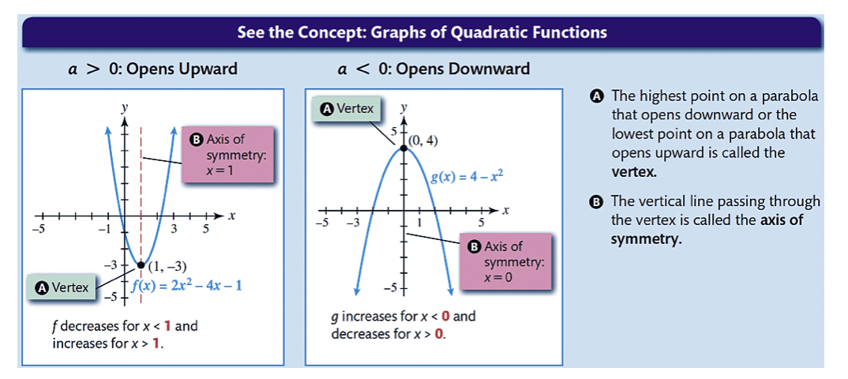

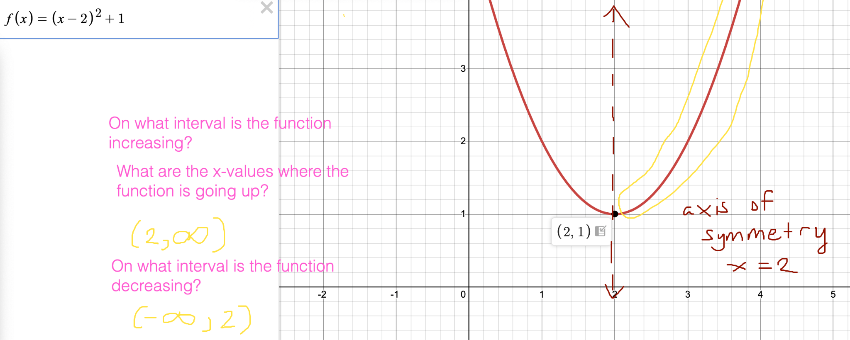

Graphing Exploration
Using a graphing calculator or desmos: Plot f(x) = ax² using various values for a like 0.5, 0.1, 0.01, 2, 3, 4, -5, -0.4. What do you notice?

The bigger the a value, the thinner the graph. And a negative value for a means that the parabola opens downward.

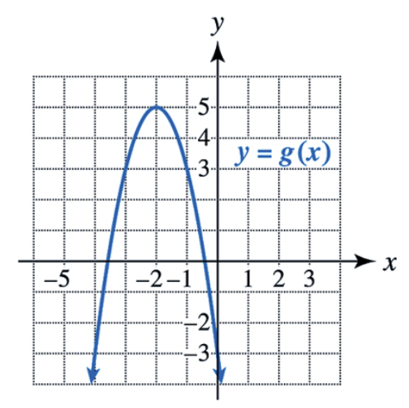
Example: Analyzing graphs of quadratic functions
Use the graph of the quadratic function to determine the sign of the leading coefficient (sign of a), its vertex, and the equation of the axis of symmetry. Give intervals where the function is increasing and where it is decreasing. Give the domain and range in interval notation.

a is negative, because the parabola is opening down.
vertex is (-2, 5)
the axis of symmetry is x = -2
increasing (-infinity, -2)
decreasing (-2, infinity)
domain (-infinity, infinity), all real numbers, R
range (-infinity, 5]

Vertex Form of a Parabola
The parabolic graph of f(x) = a(x − h)² + k with a ≠ 0 has vertex (h, k).

Its graph opens upward when a > 0 and opens downward when a < 0.

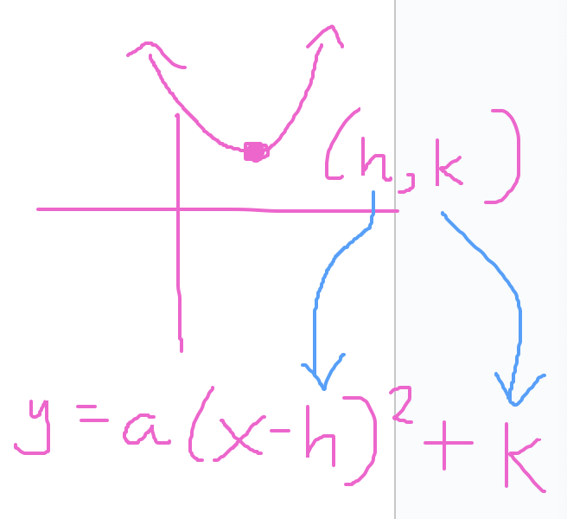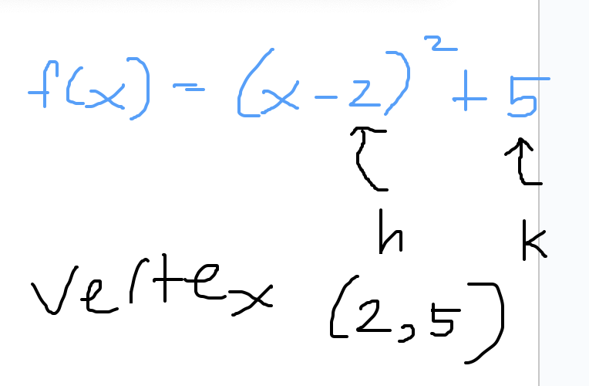

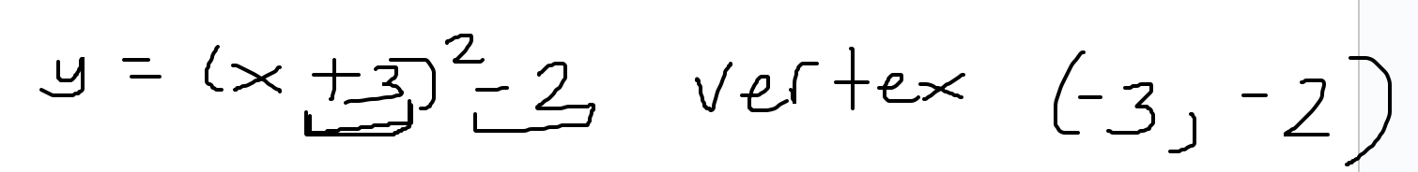

Standard Form of a Parabola

The standard form of a parabola is f(x) = ax² + bx + c.

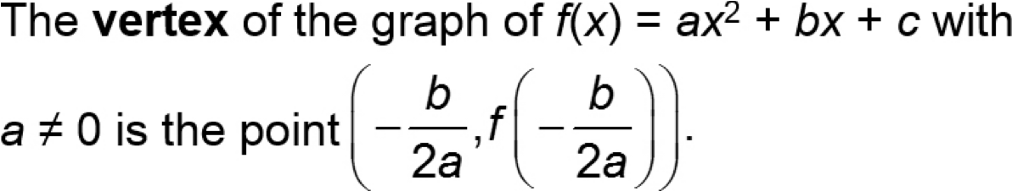

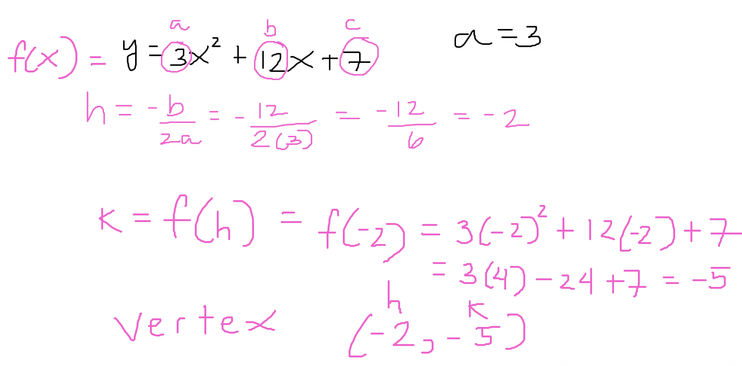

Example: Converting from standard form to vertex form
Use the vertex formula to write f(x) = 3x² + 12x + 7 in vertex form.

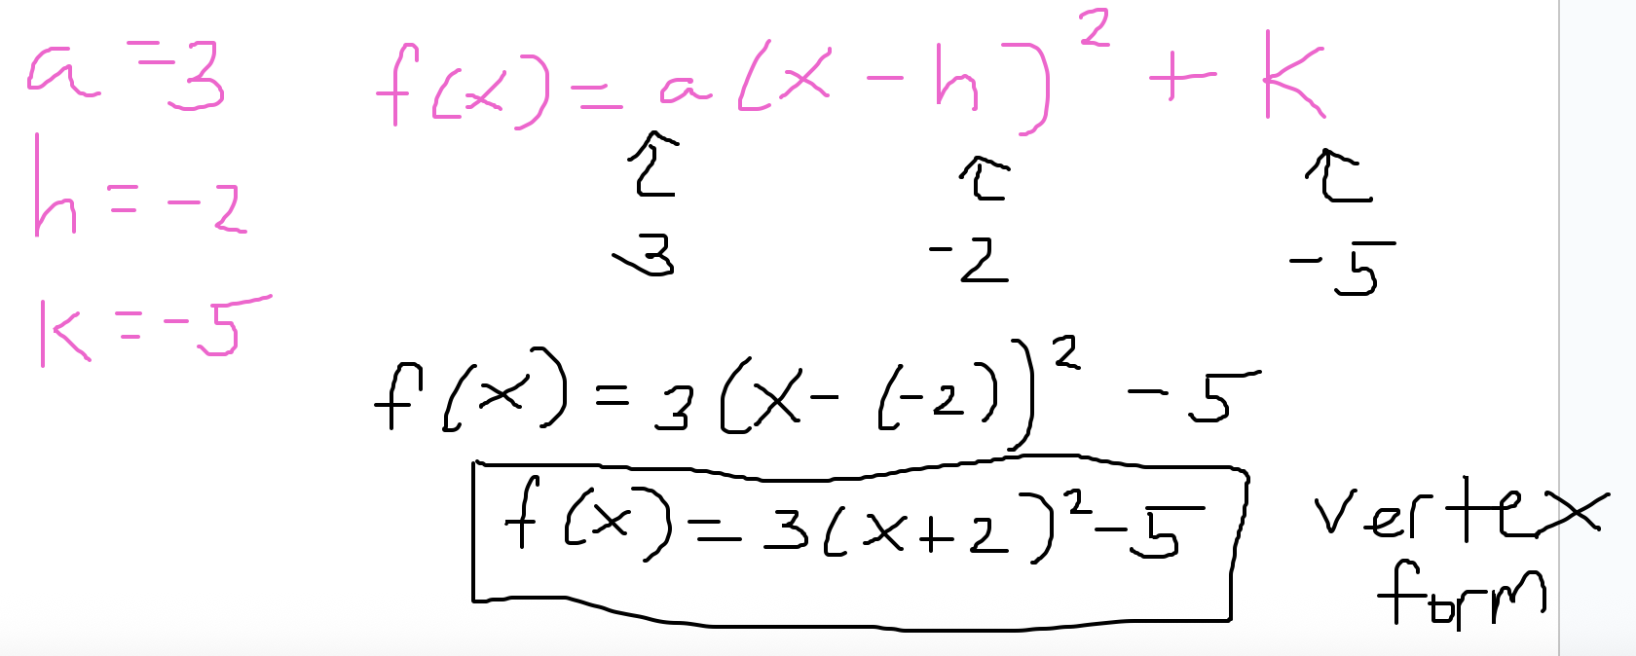

Completing the Square
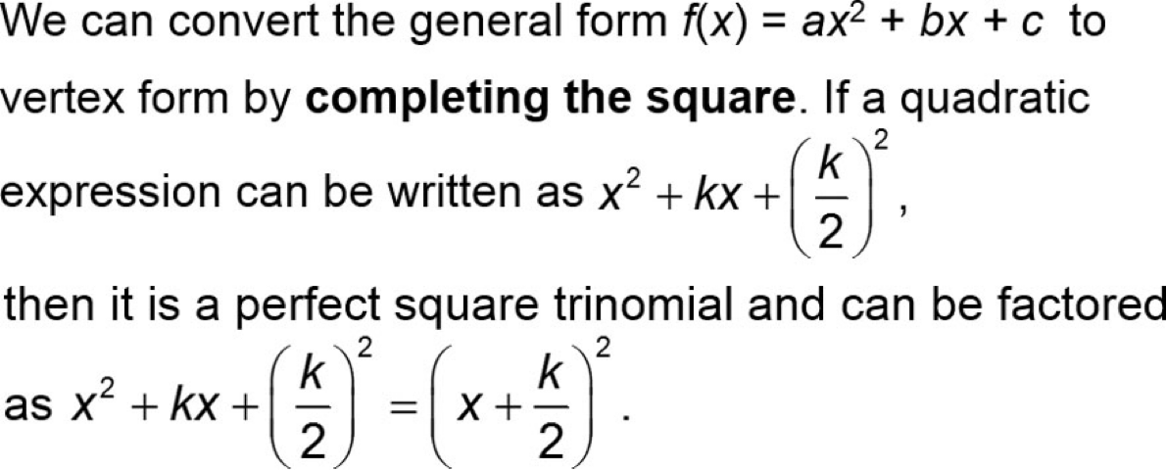

Example: Converting to vertex form by completing the square

Write the formula f(x) = x² + 6x − 3 in vertex form by completing the square. Identify the vertex.

Example: Graphing a quadratic functions by hand
Graph f(x) = -3x² + 6x - 2 by hand.

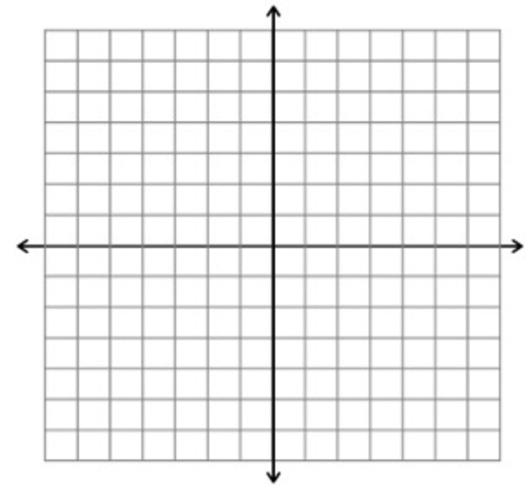

Applications and Models
Sometimes when a quadratic function f is used in applications, the vertex provides important information. The reason is that the y-coordinate of the vertex is the minimum value of f(x) when its graph opens upward and is the maximum value of f(x) when its graph opens downward.

Example: Maximizing area
A rancher is fencing a rectangular area for cattle using the straight portion of a river as one side of the rectangle. If the rancher has 2400 feet of fence, find the dimensions of the rectangle that give the maximum area for the cattle.

Example: Projectile Motion
